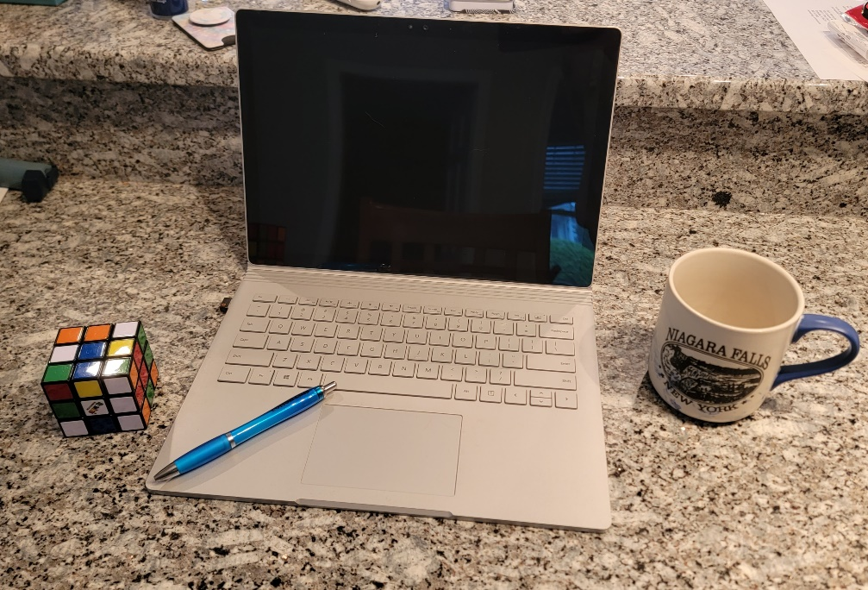

All the items in the above photo will be used to make a 3D image in OpenGL, a Rubik’s cube, a pen, a computer, and a mug. Some items are made up of singular primitive shapes while others would require multiple primitive shapes in order display the item in 3D. The Rubik’s Cube, as the name would imply, is a cube. To build this using 2D shapes I would make two triangles to form a plane then attach more planes to the edges to build the cube. The pen would be a cylinder for the base and a cone attached at one end for the tip. The computer is two planes attached to each other and the cup would be a cylinder with a torus for the handle. All items will be placed onto a plane to simulate the countertop on which the items sit in the picture. The items in the photo are simple enough where they won’t cause too many issues, but complex enough where I’ll be able to apply all the skills learned though out the course assignments.